Lab Experiments: 16-20

16.Simulate a Multimedia Network.

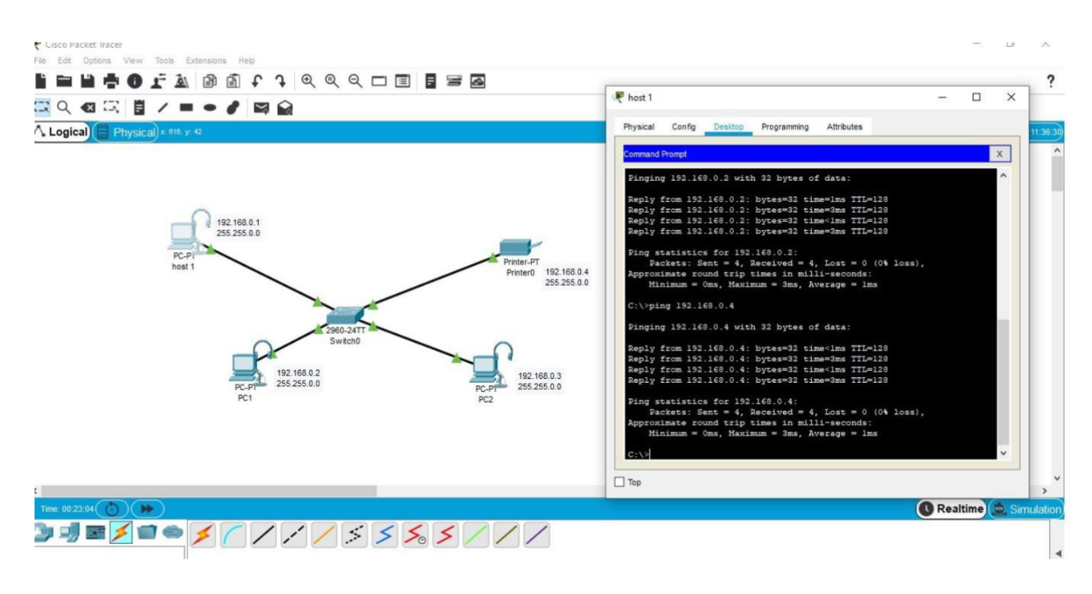

17.AAA Local &Server Based Authentication Configuration in Cisco Packet Tracer

18.IOT Based Smart Home using WPA Security & Radius Server.

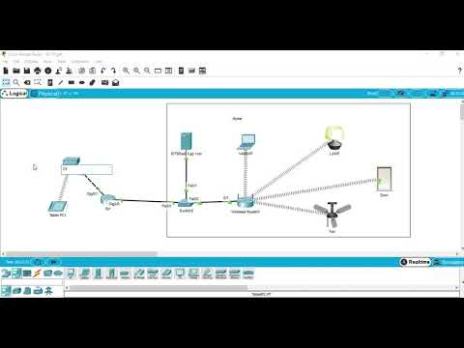

19.WLAN Using Cisco Packet Tracer.

20.Control of Fan, Light, Window & Application of Using Cisco Packet Tracer.

